VNET Peering – DEMO

Step-by-Step Configuration **for Global VNET Peering**

* Log in to the Azure portal at  [https://portal.azure.com](https://portal.azure.com/).
* Create a RG “vnet_rg1” on region “(Europe) UK South”
* Create another RG “vnet_rg2” on region “(Asia Pacific) Central India”
* Create a VNET “vnet1” based on RG “vnet_rg1”, on region “(Europe) UK South” with CIDR 10.8.0.0/23
  + Create Subnet “vnet1_subnet1” with CIDR 10.8.0.0/24
  + Create Subnet “vnet1_subnet2” with CIDR 10.8.1.0/24
* Create a VM “vm1-vnet1” based on RG “vnet_rg1”, on region “(Europe) UK South”
  + Image 🡪 Win2019
  + Username & Password 🡺 admin11 & Admin@Vnet123
  + VNET 🡺 vnet1
  + Subnet 🡺vnet1_subnet1
  + NSG 🡪 Inbound Rule 🡪 RDP : Port 3398
  + Make a note of local/private IP of this VM which maybe like 10.8.0.4 since 1st 4 Ips 10.8.0.0, 10.8.0.1, 10.8.0.2, 10.8.0.3 are reserved by Azure.
* Create a VNET “vnet2” based on RG “vnet_rg2”, on region “(Asia Pacific) Central India” with CIDR 10.9.0.0/23
  + Create Subnet “vnet2_subnet1” with CIDR 10.9.0.0/24
  + Create Subnet “vnet2_subnet2” with CIDR 10.9.1.0/24
* Create a VM “vm1-vnet2” based on RG “vnet_rg2”, on region “(Asia Pacific) Central India”
  + Image 🡪 Win2019
  + Username & Password 🡺 admin11 & Admin@Vnet123
  + VNET 🡺 vnet2
  + Subnet 🡺vnet2_subnet1
  + NSG 🡪 Inbound Rule 🡪 RDP : Port 3398
  + Make a node of local/private IP of this VM which maybe like 10.9.0.4 since 1st 3 Ips 10.9.0.0, 10.9.0.1, 10.9.0.2, 10.9.0.3 are reserved by Azure.
* Now “vnet1” **virtual network** and select **Peerings**, under **Settings**, and then select **Add.**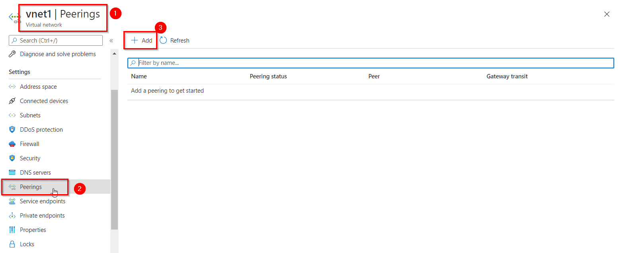

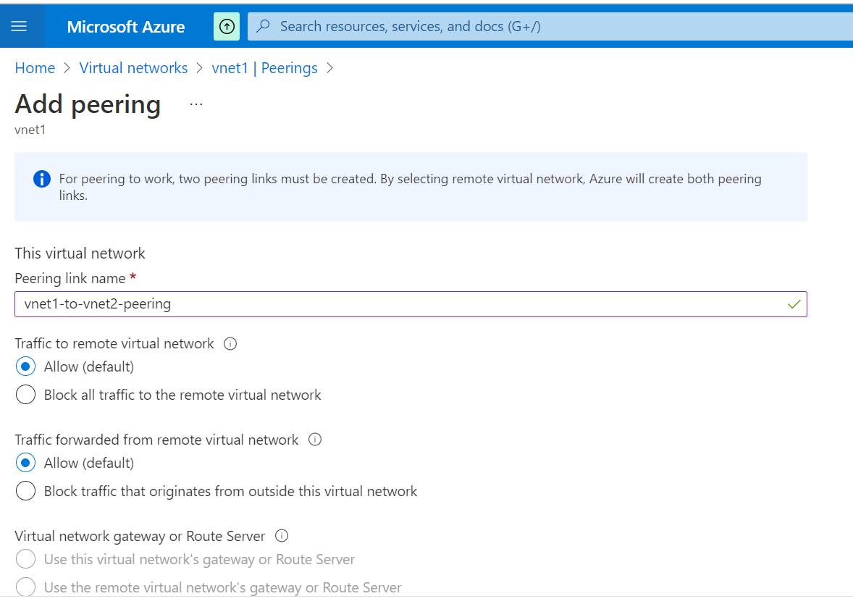

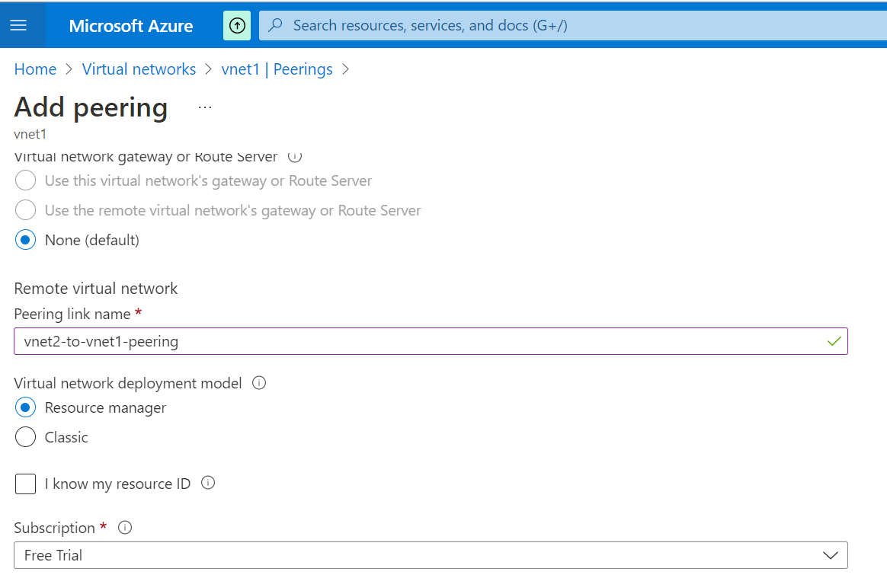

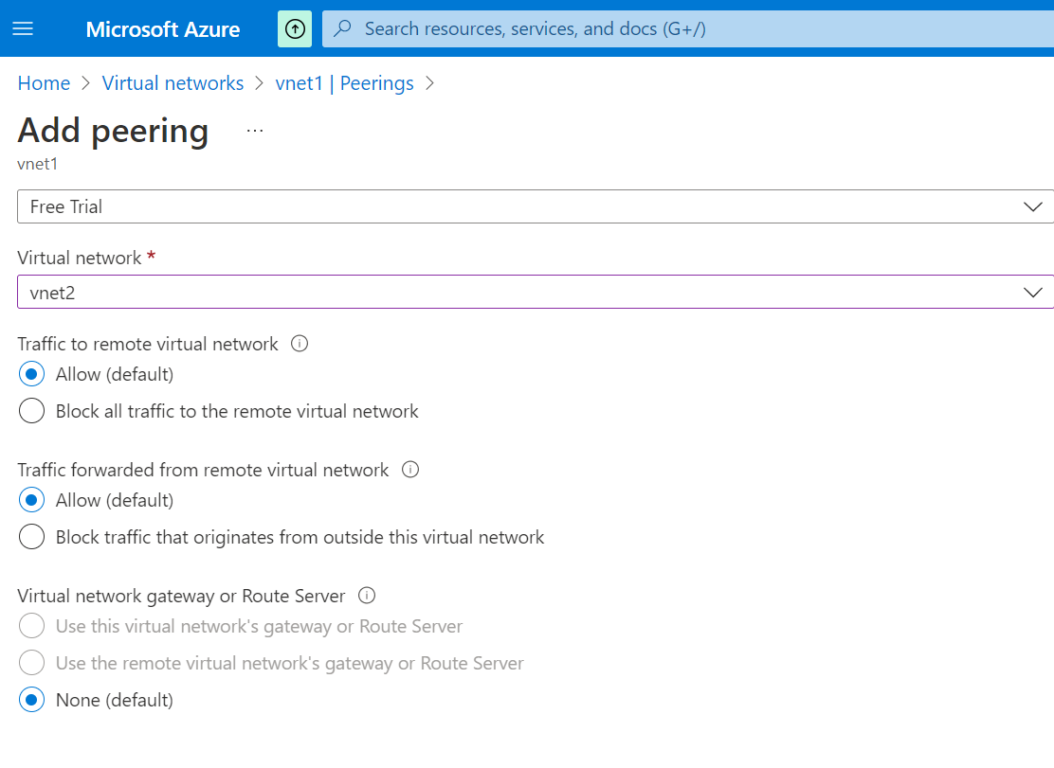

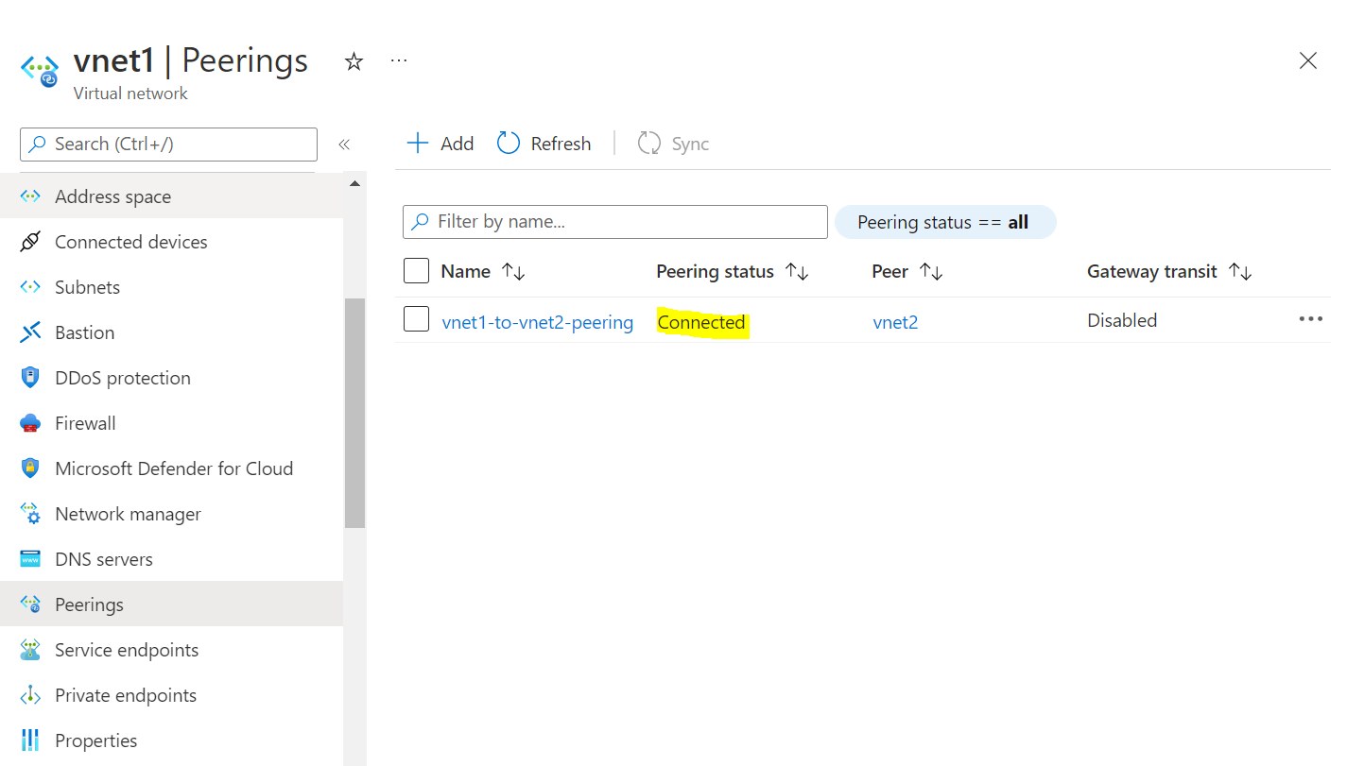

* Now RDP to VM “vm1-vnet1” which is in vnet1 then try to ping the Private / Local IP of the second VM “vm1-vnet2” to test the peering.  
  Note: If you are using a Windows Server VM, the ping will fail, because ping uses the Internet Control Message Protocol (ICMP). By default, ICMP isn’t allowed through the Windows firewall.
* To allow vm1-vnet1 to ping vm1-vnet2, follow below steps in vm1-vnet2 once you RDP to this server.
  + In search, type “Windows Firewall”
  + Select Advanced Setting and Choose “Inbound Rules”
  + Right click below rule ICMPv4 and enable it.

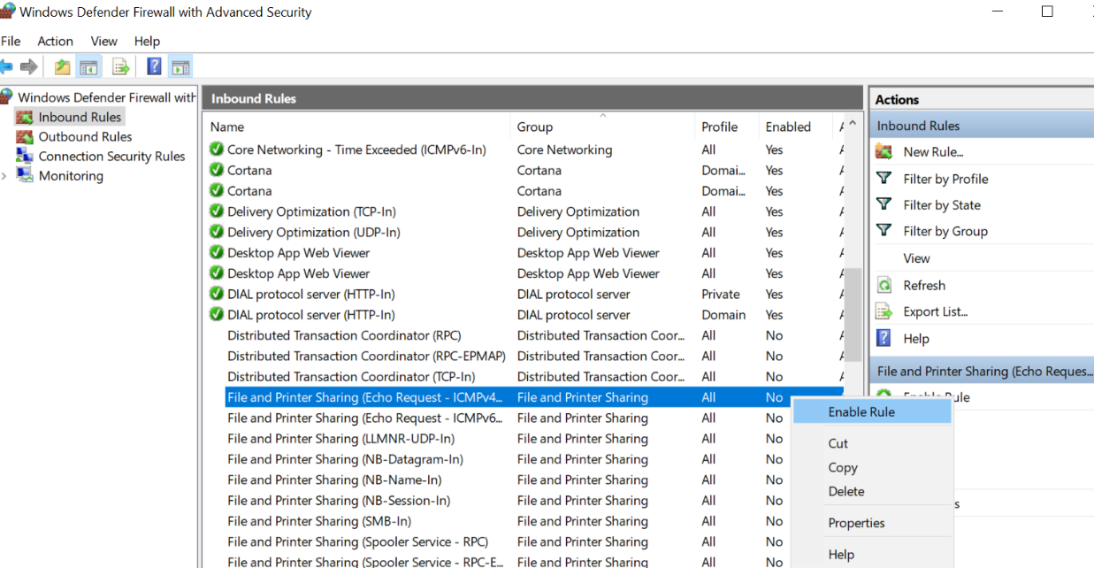

* Now, ping the “Private IP” of VM “vm1-vnet2” from VM VM “vm1-vnet1”

